Six press photographs, free of rights for editorial promotion in the press,
for the poster and for the invitation of the exhibition:

#Bischof100

by Werner Bischof

These 6 photographs may be used solely and exclusively in the context of promotion of the exhibition "#Bischof100 - 100 Jahre Werner Bischof" by Werner Bischof, presented at Photobastei Zurich, Switzerland, from April 8th to 24th 2016 beginning 3 months before the opening of the exhibition and until its end.
Only 4 of these photographs may be published copyright-free at any one time in the same issue or edition of the same medium (except for a special internal publication or exhibition guide). The size of these images should not be greater than half of one page. These images cannot be used free of rights on the cover of the publication.
On websites, the images can only be used in low resolution, and must be removed from websites at the end of the exhibition.

The images must not be cropped or digitally altered.

Neither Magnum Photos nor the photographers are responsible for image rights of the people represented.

The digital files in question have to be erased from the computers and hard drives of the lessee and from those of its partners – graphic designers, printers, etc. – at the close of the exhibition.

Caption and copyright of the images have to be mentioned.

Copyright:
© Werner Bischof/Magnum Photos

Pour toute autre utilisation, ou pour l’utilisation d’autres photographies, merci de contacter le service presse de Magnum Photos Paris, ou bien le représentant légal de Magnum Photos en Suisse (Keystone, Zurich).

Magnum Photos Paris – département presse :

Corinne Nguyen: corinne.nguyen@magnumphotos.com
T +33 (0)1.53.42.50.28

Agent de Magnum Photos en Suisse : Keystone AG
Grubenstrasse 45
CH - 8045 Zurich
Suisse
T +41 44 200 13 00
info@keystone.ch
http://www.keystone.ch/

BIW1940001W0000X/X1
(NYC54318)
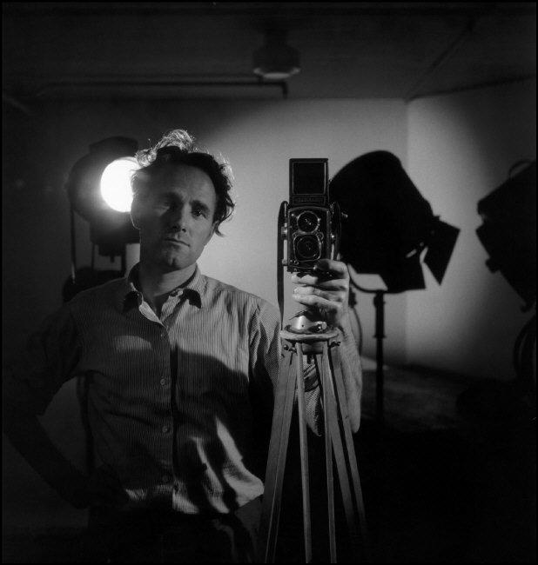
Self-portrait of Werner Bischof in his studio, Zurich, Switzerland, 1940

BIW1945002W25055C
(PAR8456)
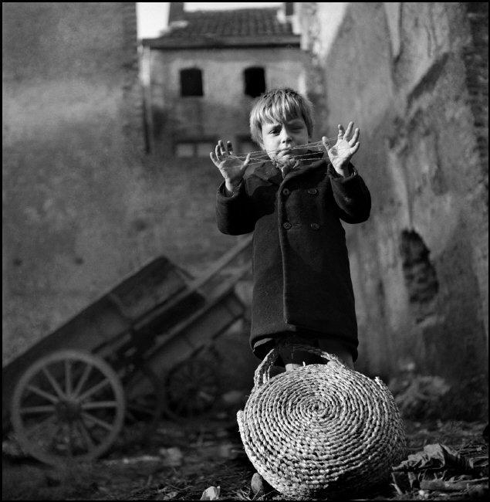
Playing criss cross, Maastricht, Netherlands, 1945

BIW1951003W51B11/12
(PAR77547)
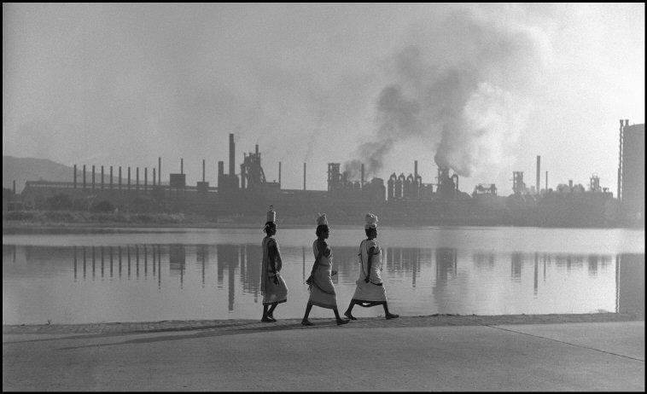
Jamshedpur, India, 1951
PAR198511
(BIW1951001K010)
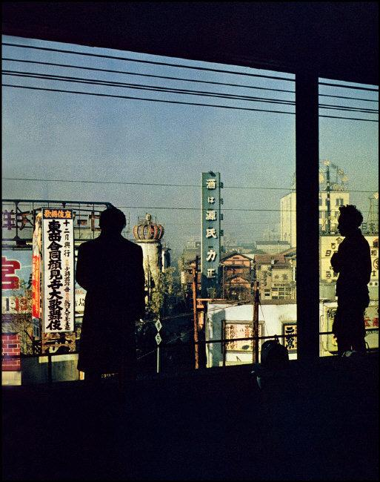
View of Tokyo, Shimbashi district, Japan, 1951

BIW1952004K001
(PAR198513)
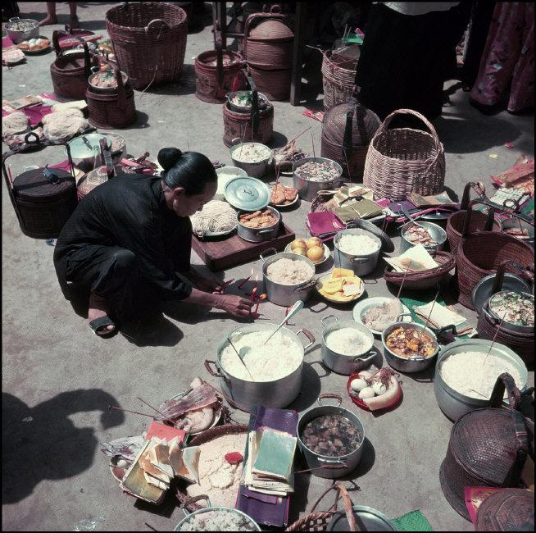
Day of the wandering souls, Hong-Kong, China, 1952

BIW1953001W00022/25
(PAR77568)
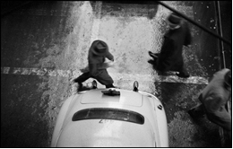
New York City, USA, 1953

